**SYNTAX OF cp command:-**

cp [OPTIONS] source destination

**EXPLANATION:-**

**cp** command is used to copy the files from source to destination.

Initially there is only one file named **Intro** in Student folder

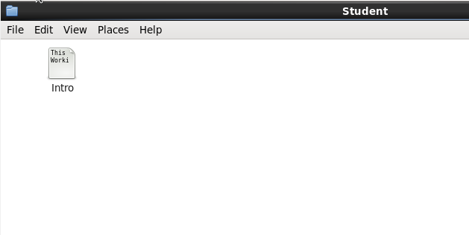

For example,

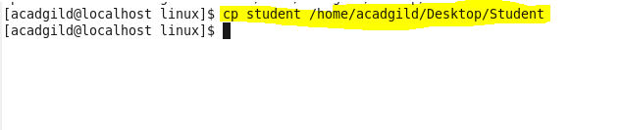

After executing the above cp command, **student** file present in **linux** folder will be copied to **Student** folder as per the below screenshot.

